A000-Pac-Poly-NZ-Maori Warrior Figure-Koa Wood-Hoko Pai sculptor-1937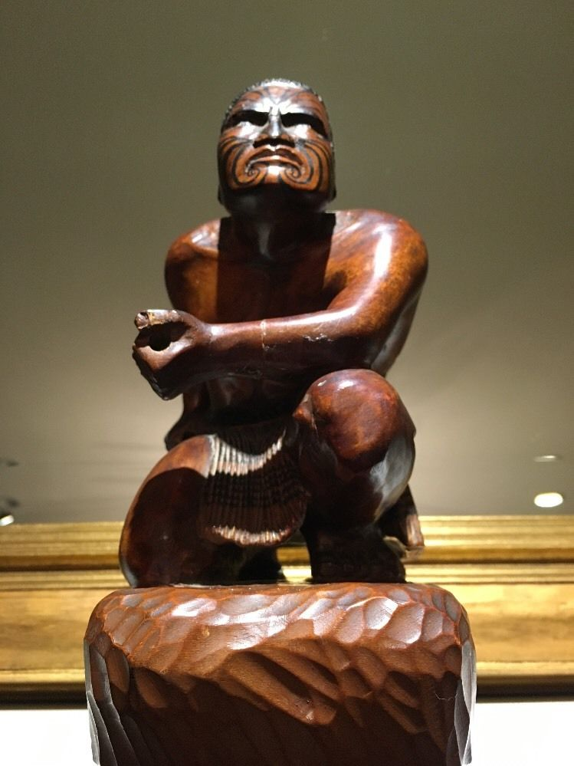 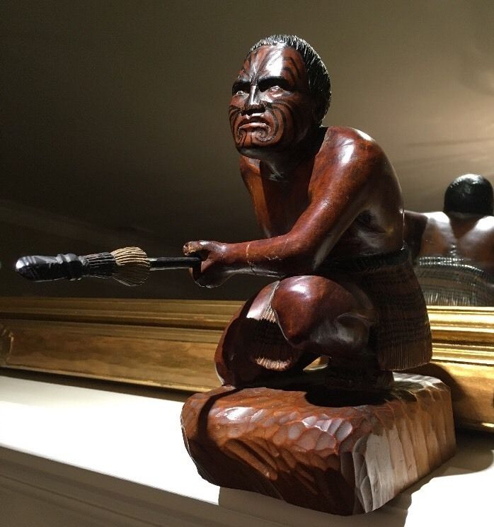 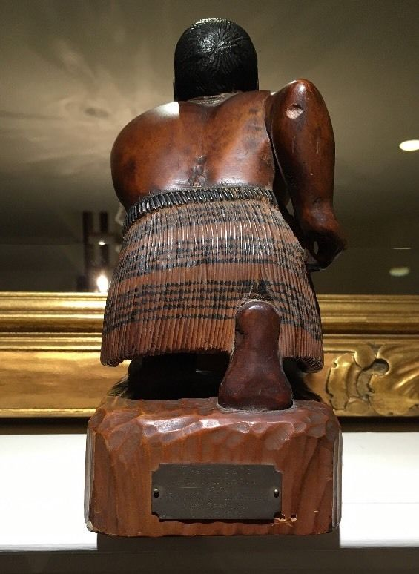 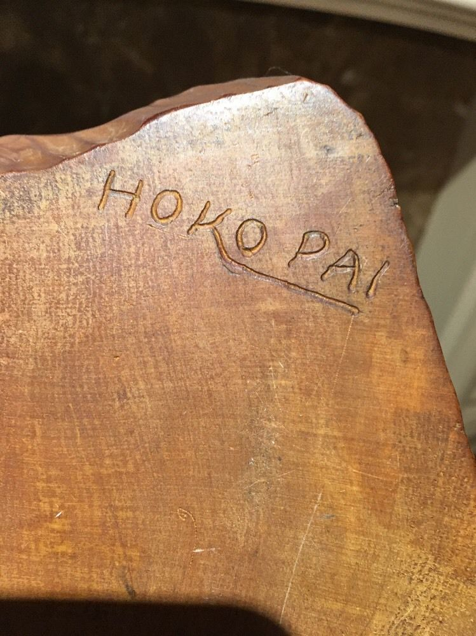 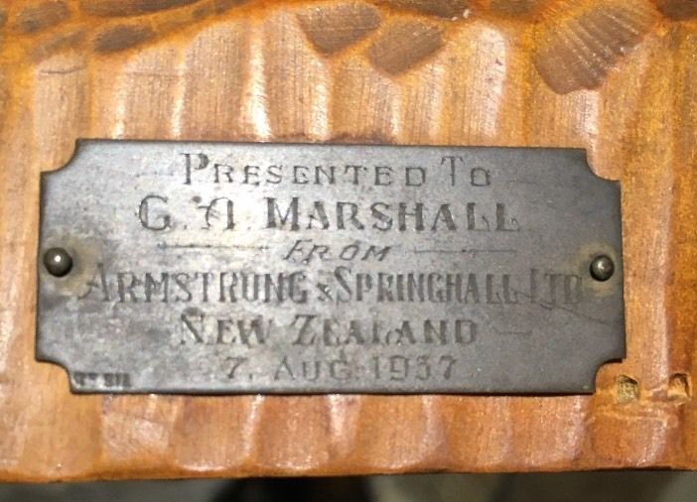

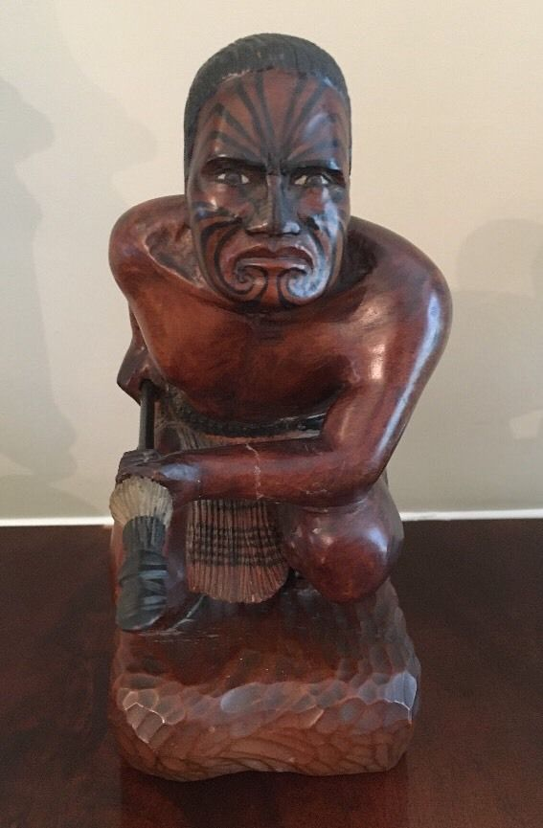

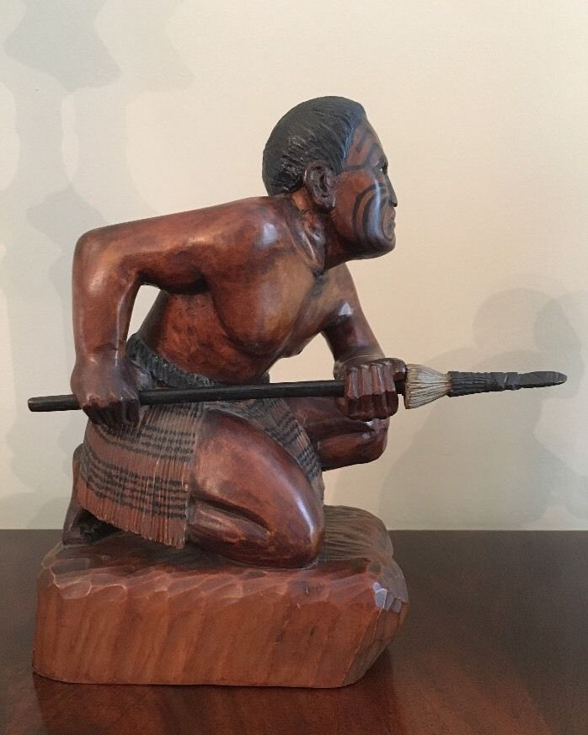

Figs, 1- 7. Pac-Poly-NZ-Maori Warrior Figure-Koa Wood-Hoko Pai sculptor-1937

**Case No.: 13**

**Accession No.**

**Formal Label:**

**Display Description:**

**This** Maori Warrior Figure sculpted in Koa Wood by Hoko Pai sculptor in 1937 is exceptional in its realism and authenticity of the objects represented.

**LC Classification:**

**Date or Time Horizon:**

**Geographical Area:**

**Map:**

**GPS coordinates:**

**Cultural Affiliation:**

**Media:**

**Dimensions:**

**Weight:**

**Condition:**

**Provenance: G. N. Marshall, 7 Aug. 1937**

**Discussion:**

**References:**